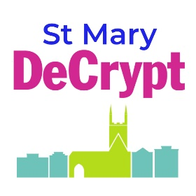The Sanc The Sanctuary Project

at the church of St Mary de Crypt,

Gloucester

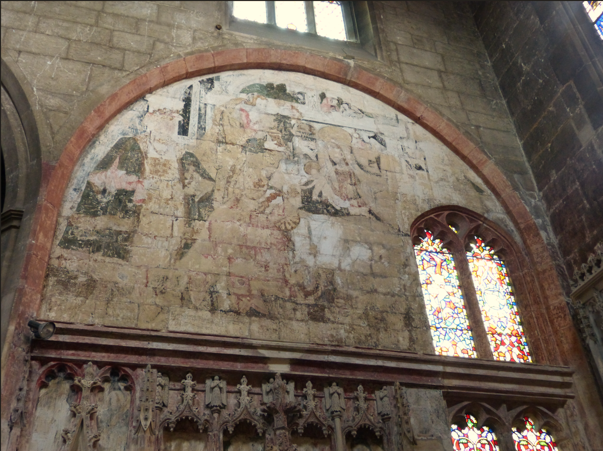

Invitation to tender as

**Conservator for wall paintings**

**October 2025**

**Overview of the Sanctuary Project**

1. **Contact**

Project Manager

Hellen O’Connor, Operations Manager

St Mary de Crypt

Southgate Street

Gloucester

Gloucestershire

GL1 1TP

hellen.oconnor@discoverdecrypt.org.uk

Tel: 01452 305235.

1. **Introduction and project requirements**

The church has secured Round 1 funding from The National Lottery Heritage Fund to develop proposals in order to deliver a scheme of repair, conservation and re -interpretation of the nationally important paintings and decorative artifacts within the Sanctuary subject to successful Round 2 grant funding in 2026.

The project involves conservation works within the Sanctuary comprising:

* conservation and interpretation of wall paintings and ceiling bosses
* masonry cleaning and repair
* fabric improvements concerning drainage etc.
* repair and conservation of leaded light windows.

The project outcomes are to:

• Undertake conservation and stabilisation works in the Sanctuary, focusing on the Tudor wall paintings, stonework, windows and floor tiles.

• Undertake resilience work to inform the organisation's long-term sustainability including staff training, appointment of a fundraiser, increasing volunteers and working with partners.

• Deliver a programme of community engagement including:

-Placements for students to assist in the conservation and stabilisation of heritage assets in the Sanctuary.

-Talks, hard hat tours and events about the history of the church and conservation project.

-Apprenticeship(s) with Gloucestershire College.

• Co-design new interpretation with project partners, volunteers and community participants.

The project team are inviting expressions of interest for QUALITY-BASED tenders with a proposed financial framework for the conservation of the nationally important wall paintings and ceiling bosses at the church.

It is intended to appoint the PROJECT CONSERVATOR for the full project to completion, but the commission will depend on successful fundraising and the project’s approval for Heritage Fund Round 2 funding, expected June 2026

Assuming the project proceeds, the successful Conservator will work under the Principal Contractor (whose appointment is yet to be made) but will assume full responsibility for the conservation of the polychromy and related areas of work. Their involvement within the pre-contract elements of the delivery-phase project will be required, and an allowance within the tender should be made for such input.

The disciplines undertaken by the Principal Contractor will include glazing, masonry and associated fabric works. They will also be responsible for access, site management, health and safety etc.

1. **Anticipated Timescale for Tender Process**

Opportunity advertised and ITT Issued: 13th October 2025

Deadline for questions on the ITT: 22nd October 2025

Tender returns: 10th November 2025

Interviews of shortlisted conservators: 17th November 2025

Confirmation of appointment c.8th December 2025

1. **Description and Historical Summary**

St Mary de Crypt church is a Grade I listed mediaeval church in Southgate Street in the centre of Gloucester. It plays a significant part in the religious and civic life of the city and has done so since it was first built about 900 years ago. The church was listed at Grade I in 1952, the list description noting that it was

*“first recorded c1140. Mainly C14, late C15 and early C16 incorporating some C12 and C13 structure and features. Extensive restoration, 1844-5, by S. W. Daukes and J. R. Hamilton, further restoration in 1866, 1876, 1903, and 1908 when the tower battlements and pinnacles were removed as unsafe. Ashlar, dressed stone in courses, slate roofs…cruciform plan; with aisled nave of three bays, south porch, crossing with tall central tower, transepts of one-bay, and chancel of three bays with slightly shorter north and south chapels, a crypt below the west end of the nave and vaults below the chancel.”*

A Norman foundation, the church was first referred to as the ‘Church of the Blessed Mary within Southgate’. In 1241 Llanthony Secunda Priory acquired responsibility for St Mary de Crypt. It made significant alterations to the building in the following 250 years culminating in extensive rebuilding of the church in the 15th Century. The church as it stands today still has some Norman traces but is largely in the Perpendicular style dating from the 15th Century.

The architectural polychromy and decorative works that form the basis of the proposed conservation project date from the early part of the 16th Century.

**Current position**

In 2010 the parish of St Mary de Crypt was one of three Gloucester parishes which were amalgamated to form the single parish of Hempsted with St Mary de Lode and St Mary de Crypt, Gloucester. St Mary de Crypt was closed for use in 2017 allowing for the start of an ambitious £2.1 million project to repair and reorder both the church and the schoolroom. After several years of planning and fund raising, including securing a grant from The National Lottery Heritage Fund, the building works were carried out in 2018 – 2019, which included installation of WCs, staircase and lift, a new heating and lighting system within the church and schoolroom, removal of the pews, new flooring to the nave including conservation of the ledger stones, and access improvements. St Mary de Crypt church and the Tudor Schoolroom reopened to the public on 19th March 2019 to be known as Discover DeCrypt, a community centre run by Discover De Crypt CIO.

The church and the schoolroom are available to hire for concerts, recitals, theatrical performances, exhibitions, talks, and any social event which is compatible with the church’s mission. The church and the schoolroom are also a tourist attraction drawing in many local people and visitors from further afield. Discover DeCrypt welcomed 22,800 visitors in 2023 in addition to groups who use the building on a regular basis. Although Discover DeCrypt CIO owns the schoolroom and manages the community centre events in the church and the old school room, ownership of the church remains vested in the Incumbent and she and the PCC retain responsibility and authority with regard to the use and upkeep of the church building. St Mary de Crypt is now a chapel of ease rather than a parish church.

1. **Records and documentation**

The PCC have commissioned a number of reports in preparation for this project concerning the various aspects of the Sanctuary. The following are available to interested parties and should be reviewed by those tendering:

* Rickerby, Stephen and Shekede, Lisa: *‘Technical Examination of Wall Paintings and Architectural Polychromy’*, July 2025
* Rickerby, Stephen and Shekede, Lisa: *‘Condition Assessment of Wall Paintings and Architectural Polychromy’*, July 2025
* Henderson, Fiona for Tobit Curteis Associates LLP: *‘Assessment of the Environmental Conditions Associated with the Conservation of the Wall Paintings and Historic Fabric in the Sanctuary’*, May 2025
* Carrington, David for Skillington Workshop: *‘St Mary de Crypt church, Gloucester: Condition report on the Sanctuary Interior Stonework’* January 2022
* Clare, Stephen and Clare, Jack *‘Survey of Chancel Glazing, St. Mary de Crypt, Gloucester’* December 2021

Responses to the ITT should be aligned to tenderers’ interpretation of these reports and how these would relate to their ways of working and ultimately their successful delivery of the project.

1. **Quality**

The PCC and project team are keenly aware that the conservation of the wall paintings at the church is a unique challenge. The work that will be carried out in this project must not only endure for many years with only minimum intervention but any shortcomings in the work has the potential for irreversible damage.

The selection of appropriately qualified consultants, conservators and other contractors is therefore critical to the eventual success of the project, hence the weighting of the review of tenders being towards the quality of the proposals.

1. **Training, Learning and Interpretation**

This project offers excellent opportunities for training in heritage skills, notably conservation of polychrome artworks and features from the pre-Reformation period.

All contractors and conservators will be required to include training, interpretation and community engagement in their work and selection criteria will include the quality of their offer in this respect. The successful tendering conservator will be expected to work with both the project team and the Principal Contractor to provide sufficient training opportunities in their specialism. Student placements and participation should form a significant part of the commission.

1. **Outline Scope of Conservator’s Appointment**

* Implement the conservation works generally in accordance with the Conservation Report.
* Collaborate with and work within the contractual requirements of the Principal Contractor during the delivery of the conservation works.
* Provide regular reports on progress and costs to the project team to ensure that the project is delivered to the highest quality on time and within budget.
* Liaise throughout the project with the project manager and conservation architect to ensure effective delivery of all aspects of the project including learning, training and interpretation programmes.
* Manage and ensure quality control of student placements
* Contribute to project evaluation
* Note that invoicing post-contract will be paid through the contract with the Principal Contractor

1. **Submission Requirements**

Tenderers are expected to review the current reports that are listed above and specifically those relating to the wall paintings *‘Technical Examination of Wall Paintings and Architectural Polychromy’;* and *‘Condition Assessment of Wall Paintings and Architectural Polychromy’* – alongside their own assessment of the condition of wall paintings and decorative features within the Sanctuary. Site visits are encouraged, but access above normal floor level will not be possible at this stage. As part of their submissions, tenderers shall provide the following:

1. Prioritised recommendations for the conservation of the polychromy and decorative features, describing their ways of working and how these respond to the current reports. *Include a case study of a previous project you have delivered where similar approaches have been used.* (max 1,000 words) **40%**
2. Explanation of how you would utilise the project for training and learning opportunities aligned with the expectations of the ‘project outcomes’ outlined above. *Include a case study of a previous project you have delivered where high quality learning opportunities have been provided.* (max 750 words)

**25%**

1. Description of how you will work with the project team and Principal Contractor to deliver the project *Include a case study of a previous project you have delivered working as a subcontractor or main contractor as part of a multi-disciplinary team* (max 750 words)

**20%**

1. A framework of costs for the delivery of the project should be given which should also identify any costs that are not fixed and also any inflationary mechanisms that might be employed given that the conservation works are not likely to be on site until Q1-Q2 of 2027

**15%**

**10 Project Budget**

The indicative budget of £100,000 is anticipated to cover the scope of conservation works in this brief including fees and expenses.

**11 Overall Project Programme and Phasing**

Conservator appointed: December 2025

Faculty Consent approved: January 2026

Heritage Fund Round 2 submission: February 2026

Heritage Fund Round 2 decision: June 2026

Appointment of main Contractor October 2026

Environmental preliminary work January 2027

Scaffolding April 2027

Conservation work April – November 2027

Project finishes August 2028

**12. Inspection and Site Visit**

Site visits during preparation of the tenders are encouraged and arrangements for access should be made with Hellen O’Connor as noted above.

**13. Questions**

All questions relating to this PQQ must be submitted in writing by the 22nd October 2025.

**14. Summary Selection Procedure**

The selection procedure will to be based on a review of the submissions detailed in Section 9 by the project board. Items 1-3 will be weighted 85% and 4 will be 15%.

Up to 3 shortlisted parties will be interviewed and following this the selection will be made. There may need to be a consideration of the shortlisted parties by the DAC as well as the project board.