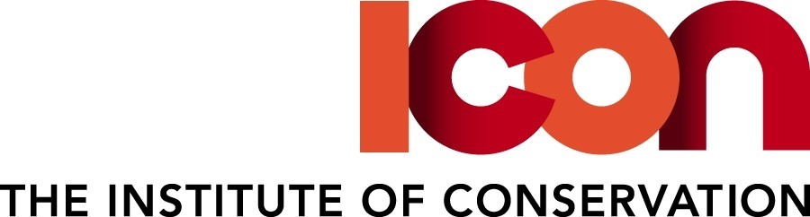

RECORDING CONSENT FORM: Events
Icon aims to champion excellence and high professional standards in the practice of conservation. Icon regularly creates and shares resources with its members and the public.
The purpose of this form is to seek your consent to record your participation in the Institute of Conservation event and your permission to use such recording in the future, including any material you share within the recordings. We want to use the recording to increase the knowledge and skills of the conservation sector and ensure the recordings are made available for those unable to attend.
[If would like you to submit a photograph of yourself to promote the Event before it is recorded. You will need to obtain copyright permission from the photographer to submit the photograph where it is not your own original work.]
Event: …………………………………………………………………………………………………………………………………….
By signing this form, I agree to the following:
- I hereby grant permission to Icon to record my image and voice by making a photographic, audio or video recording of the Event (Recording).
- I warrant that any material that I decide to use in the Recording, including any text passages and images in my presentation [and any photograph I submit of myself] does not infringe copyright and I have obtained the necessary permissions to share them.
- I waive any right to royalties or other compensation which may arise related to the use of my image or the Recording.
- I agree that the Recording can be used throughout the world and in all media to promote the Event and for educational and research purposes, including
- Icon’s website
- Icon’s social media channels, including but not restricted to YouTube
- Educational presentations or courses, including online education
- Clips from Recording may be used for promotional activities
- I agree that the Recording may be edited, copied, translated, exhibited, published, distributed or broadcast for the purposes set out in this form and I waive the right to inspect or approve the finished product wherein my likeness or recorded voice appears.
- I agree that Icon can pass the Recording to third parties, including external press and media agencies, publishers and broadcasters for the purposes set out in this form.
- I accept that the Recording of me may be retained by Icon as long as is necessary for education and research purposes.
- I understand that copyright in the Recording will be owned by Icon.
I understand I may in future request that material containing my personal data that is in the control of Icon is removed from its website by emailing the Communications Officer at geanina.beres@icon.org.uk
By signing this Recording Consent form, I agree to the terms set out above:

Signed by: ...................................................................................... Date: ..............................
Name in block capitals: .................................................................

The personal data on this form will be used by Icon for the sole purpose of managing copyright. It will not be passed to a third party without your permission. Any personal data collected in this form will be processed in accordance with the Data Protection Legislation (Data Protection Act 2018 and UK GDPR) as outlined in the Icon Privacy Statement

