Collaborative Conservation Skills Internship Programme
Host Application Form

Please complete and return this form to accreditation@icon.org.uk by 6 May 2025 at 9am. If you have any questions, please don’t hesitate to get in touch via email on the above address.

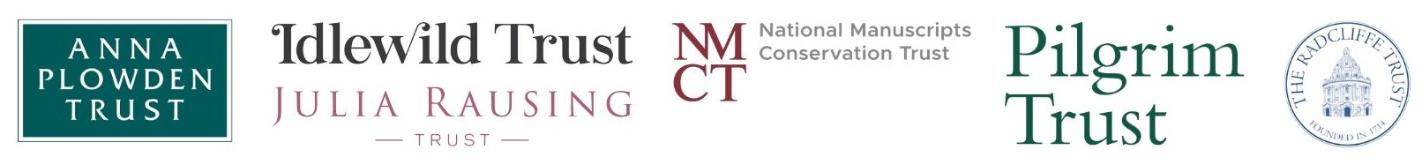

Applicant details

Name
Job Title
Organisation
Address
Email
Phone Number

About your organisation

Please provide a brief outline of your organisation, including the nature of your collections.
No more than 200 words

Please provide a brief outline of your conservation workforce, including key staff members who will support the intern during the placement.
No more than 200 words

The Internship Opportunity

Material Specialism
Name of supervisor
Membership status | Icon Accredited / Pathway Member / Other Accreditation / None
Start date
End date
Management | Self-managed / Icon-managed

Please outline the specific opportunity you are able to offer the intern, including details of the projects they will work on during the internship.
No more than 300 words

Enrichment Activities (Self-Managed Internships Only)

£5,000 is available for organisations following the Self-Managed route to support enrichment activities that contribute to the intern’s continuing professional development. Examples include:

- Attendance at training courses, workshops, or conferences.
- Participation in professional networking events or study visits.
- Visits to other heritage organisations or conservation studios to gain wider sector experience.

Please outline the activities you plan to offer and how they will support the intern’s learning and development. Please add rows as appropriate

Activity | Costs | Benefits to the intern
Please describe the opportunity | Please outline the costs associated with the opportunity | Please describe how the intern will benefit.

Declaration

Name
Job Title
Date

