Collaborative Conservation Skills Internship Programme
Host Application Form

Please complete and return this form to accreditation@icon.org.uk by 18 May 2026 at 9am. If you have any questions, please don’t hesitate to get in touch via email on the above address.
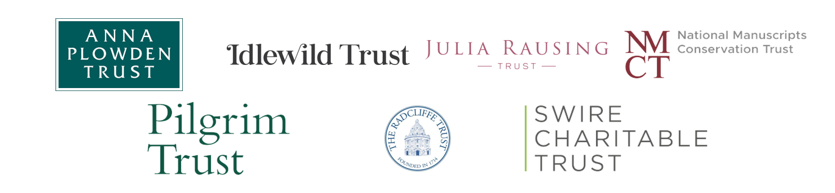
Applicant details

Name
Job Title
Organisation
Address
Email
Phone Number

About your organisation

Please provide a brief outline of your organisation, including the nature of your collections.
No more than 200 words
The Internship Opportunity

Material Specialism
Start date
End date
Management | Self-managed / Icon-managed

Please describe the internship opportunity you will offer, including the projects and activities the intern will be involved in.
No more than 300 words

Placement Supervision

Supervisor Name
Job Title
Membership status | Icon Accredited / Pathway Member / Other Accreditation / None

Please describe the supervisor’s professional experience relevant to the internship opportunity, including any relevant qualifications.
No more than 150 words

Please outline the supervisor’s experience in mentoring, supervising, and supporting early-career conservation professionals.
No more than 150 words

Enrichment Activities (Self-Managed Internships Only)

£5,000 is available for organisations following the Self-Managed route to support enrichment activities that contribute to the intern’s continuing professional development. Examples include:

- Attendance at training courses, workshops, or conferences.
- Participation in professional networking events or study visits.
- Visits to other heritage organisations or conservation studios to gain wider sector experience.

Outline the activities you plan to offer, explaining how they will support the intern’s learning and development. Please add rows as appropriate

Activity | Costs | Benefits to the intern
Describe the opportunity | Outline the costs associated with the opportunity | Describe how the intern will benefit from this activity.

Declaration

Name
Job Title
Date

