Collaborative Conservation Skills Internship Programme
Host Application Form

Please complete and return this form to accreditation@icon.org.uk by 6 May 2025 at 9am. If you have any questions, please don’t hesitate to get in touch via email on the above address.

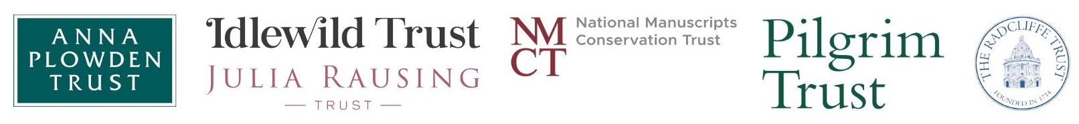

Applicant details

Name
Job Title
Organisation
Address
Email
Phone Number

About your organisation

Please provide a brief outline of your organisation, including the nature of your collections.
No more than 200 words

Please provide a brief outline of your conservation workforce, including key staff members that the internship will be supported by during the internship.
No more than 200 words

Name of supervisor
Status | Icon Accredited / Pathway Member / Other Accreditation / None

Overview of internship opportunity

Material Specialism | Musical Instruments / Manuscripts

Please outline the specific opportunity that you are able to offer the intern, including the specific projects that the intern would be able to work on during their internship.
No more than 300 words

Management model

There are two funding models which have been agreed upon. The model chosen is at the discretion of the host organisation.

Management | Self-managed / Icon-managed

Declaration

Name
Job Title
Date

